Hanoi University of Science and Technology
School of Information and Communication Technology

Software Requirement Specification – SRS

Visualization of Algorithms
Minimum Spanning Tree and Shortest Path in Graph Theory

Subject: Software Engineering

Nguyễn Duy Tiến – 20194857
Trần Quang Hải – 20194755
Trần Lâm - 20194787

Table of contents

Table of contents 1
1 Introduction 2
1.1 Purpose 2
1.2 Scope 2
1.3 Glossary 2
1.4 References 3
2 General description 4
2.1 Agents 4
2.2 Use case overview diagram 4
2.3 Use case decomposition diagram 5
2.3.1 Use case “Choose algorithm” 5
2.3.2 Use case “Set parameters” 5
2.4 Professional process 6
2.4.1 Process: Set Parameters by Text 6
2.4.2 Process: Visualize 6
3 Specification of functions 7
3.1 Specification of use case UC001 “Choose algorithm” 7
3.2 Specification of use case UC002 “Set parameters” 8
3.3 Specification of use case UC003 “Visualize” 10

Introduction

Purpose
This document provides a detailed description of the User Management Module, the user group, and their functions available at run time. Document describing the purpose and features of the system, interfaces, and constraints of the system to be implemented in response to external stimuli.

Scope
The purpose of the software is to create the user management module, the role of the user, and the functions that the user / user role can use at runtime.
This software is open to everyone, thus the users do not need to create an account to log in. Each time the user selects a function on the menu, the interface corresponding to that function will be displayed.

Glossary
- Undirected graph: a set of vertices and a collection of edges that each connect a pair of vertices
- Directed graph: A directed graph (or digraph) is a set of vertices and a collection of directed edges that each connects an ordered pair of vertices.
- Minimum spanning tree: A minimum spanning tree (MST) of an edge-weighted graph is a spanning tree whose weight (the sum of the weights of its edges) is no larger than the weight of any other spanning tree
- Shortest path: Given a connected, undirected graph G, a shortest-path tree rooted at vertex v is a spanning tree T of G, such that the path distance from root v to any other vertex u in T is the shortest path distance from v to u in G

References
- Algorithms, 4th Edition by Robert Sedgewick and Kevin Wayne
- SRS-UGMS-Sample-VN.doc, Nguyen Thi Thu Trang

General Description

Agents
This software has only one agent, which is the user. They have full functionality to interact with software via the Graphical User Interface.

Use case overview diagram
The user can choose the algorithm that they want to be performed, setting the parameters needed and ask the software to visualize through each process of the algorithm. To set the parameters, user can choose either entering raw data by text or generating by drawing graph.
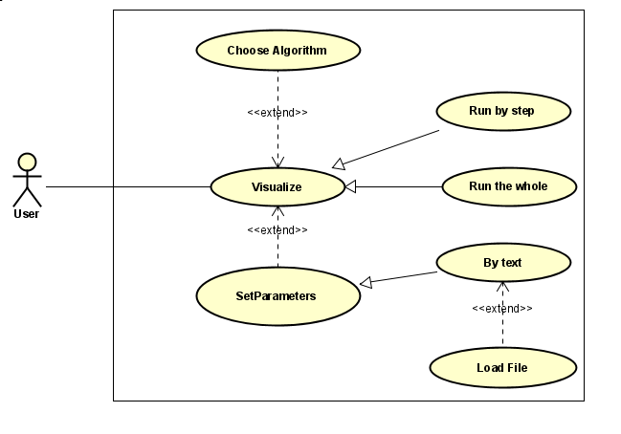
The use cases in this general use case diagram are the composite use cases of a group of use cases. Details of these use cases are given in the breakdown diagrams in the following section.

Use case decomposition diagram

Use case “Choose Algorithm”
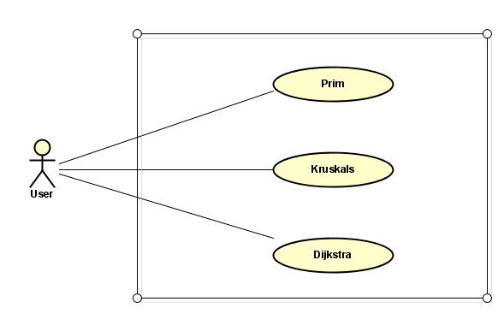

Use case “Set Parameters”
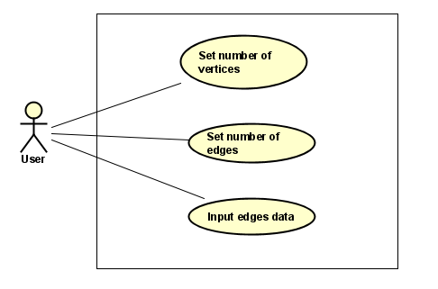

Professional process

Process: Set Parameter by Text
Firstly, the user will determine input parameters by setting number of vertices in the graph, anh then the number of edges. If the number of edges is out of possible range (too many / too few edges), the system will ask the user to reenter number of edges. After that, the user will generate data for the edges (begin vertex, end vertex, weight).
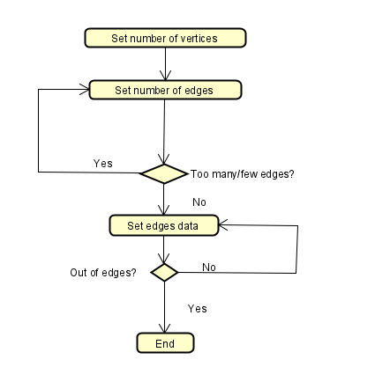

Process: Visualize
The system get input from user and then convert to text data type. The data is taken by the program to run the draw graph step. The system with a chosen algorithm will run for loops till the end of the visualization.
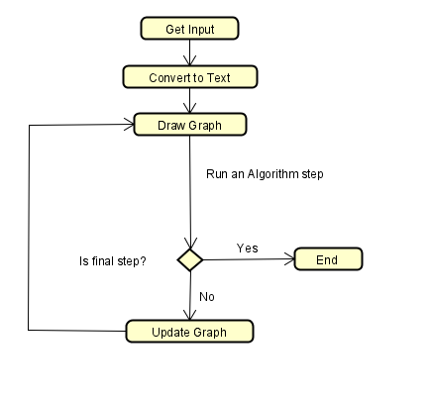

Specification of functions

Specification of use case UC001 “Choose Algorithm”
Use case code | UC001 | Use case name | Choose Algorithm
Agent | User
Prerequisite | By default is the graph of Prim Algorithm – undirected graph
Main flow of event  (Success)
  No. | Performed by | Action
   | User | Choose function “Choose Algorithm”
   | System | Display the interface
   | User | Choose an algorithm from: Prim, Kruskal, Dijkstra
   | System | Display the GUI for the user to continue with generating parameters
Alternate flow of event
  No. | Performed by | Action
Postrequisite | No

Specification of use case UC002 “Set parameters”
Use case code | UC002 | Use case name | Set parameters
Agent | User
Prerequisite | No
Main flow of event  (Success)
  No. | Performed by | Action
   | User | Choose function “Set parameters”
   | System | Display the interface
   | System | Ask the user to enter number of vertices
   | User | Enter number of vertices
   | System | Ask the user to enter number of edges
   | User | Enter number of edges
   | System | Check if the number of edges is valid
   | System | Ask the user to enter edges data : begin & end vertice, weight
   | User | Enter edges data
  10 | System | Check if the data of edges is valid
  11 | System | Display GUI with options
Alternate flow of event
  No. | Performed by | Action
  7a. | System | Notify error: number of edge is invalid. Require user to check number of edge
  10a. | System | Notify error: data of edges is invalid. Require user to check the data entered
Postrequisite | No

Specification of use case UC003 “Visualize”
Use case code | UC003 | Use case name | Set parameters
Agent | User
Prerequisite | The input parameters are set
Main flow of event  (Success)
  No. | Performed by | Action
  1 | System | Display the default graph
  2 | System | Set default algorithm
  3 | User | Configure settings
  4 | User | Choose “Run” mode
  5 | System | Visualize the graph
Alternate flow of event
  No. | Performed by | Action
  3a | User | Set algorithm
  3b | User | Set parameters
  4a | User | Choose “Run one step”
  4b | User | Choose “Run” (all steps)
  4c | User | Choose “Reset graph”
  5a | System | Visualize next step
  5b | System | Visualize all steps
  5c | System | Reset to initial graph
Postrequisite | No

